Exeter Exome Sequencing Request Form

Sample requirements: Please send at least 10µg DNA or EDTA blood to: Prof. S. Ellard, Molecular Genetics Laboratory, RILD level 3, Royal Devon & Exeter NHS Foundation Trust, Barrack Road, Exeter EX2 5DW rde-tr.MolecularGeneticsAdmin@nhs.net
- We welcome enquiries – please contact Professor Sian Ellard (Sian.Ellard@nhs.net or 01392 408259) and Dr Emma Baple (ebaple@nhs.net or 01392 405749) to discuss cases
- Prices include co-segregation analysis and confirmatory testing by Sanger sequencing or droplet digital PCR (for CNVs)
- We use the Agilent capture technology which can detect partial/whole gene deletions in addition to base substitutions and small insertions/deletions
- Non-NHS referrals will incur a 25% surcharge
CLINICIAN DETAILS
CLINICIAN NAME: |  | TELEPHONE:
E-MAIL ADDRESS FOR REPORT (nhs.net): |  | LABORATORY EMAIL ADDRESS FOR REPORT (nhs.net):
PEDIGREE & CLINICAL DETAILS
PLEASE PROVIDE A PEDIGREE AND FULL DETAILS OF THE CLINICAL PHENOTYPE, DIAGNOSES UNDER CONSIDERATION AND PRIOR INVESTIGATIONS (GENETIC AND NON-GENETIC, FOR EXAMPLE NEUROIMAGING) TO AID THE INTERPRETATION OF VARIANTS. WHERE POSSIBLE PLEASE SEND THE MOST RECENT SUMMARY CLINIC LETTER WITH THE EXOME REQUEST FORM:

ETHNIC ORIGIN: | CLINICAL GENETICS NUMBER: |  | PLEASE TICK IF URGENT

WHICH EXOME TEST? (for further information see http://www.exeterlaboratory.com/test/exome-sequencing-services)
Trio analysis £1,995  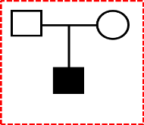  23, 244 genes (Agilent v6 exome)  Exome sequencing for an affected proband and their unaffected parents to identify de novo heterozygous, compound heterozygous, homozygous or X-L recessive disease-causing variants. |  |  | Affected sib pair analysis in consanguineous families £1,595 23,244 genes (Agilent v6 exome)  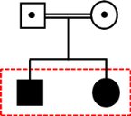  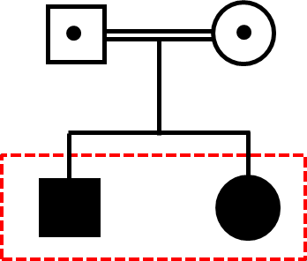  Exome sequencing for two affected siblings followed by co- segregation analysis of likely disease-causing variants in the parents and additional affected or unaffected siblings. A homozygosity analysis is performed to identify autozygous regions.
Couple analysis for lethal fetal disorders £1,595
23, 244 genes (Agilent v6 exome)

Exome sequencing for a couple who have had one or more pregnancies affected with a lethal, presumed autosomal recessive disorder (Ellard et al 2015 Eur J Hum Genet PMID 24961629). Our strategy identifies genes where both parents have a heterozygous potentially pathogenic variant. Likely disease-causing variants are then tested in the affected fetus(es) and any unaffected siblings to confirm co-segregation. This approach conserves precious fetal samples and/or is appropriate for cases where fetal DNA is of insufficient quality or quantity for exome sequencing.
Price:
£1650: “whole” exome (23,243genes)*
£1320: rare disease exome
(6,110 genes) *

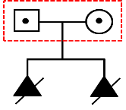
This strategy is most likely to yield a diagnosis for unrelated couples with multiple affected fetuses but has been successful for couples with a single affected pregnancy or who carry the same heterozygous disease-causing variant.
Bespoke virtual gene panel £850-£1,300
Price according to gene panel size and exome capture (6,110 known disease genes or 23, 244 genes “whole” exome)

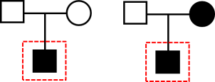
This is the only option for some families due to sample availability or pedigree structure. A virtual gene panel can either be provided by the clinician, a bespoke design based on phenotype (we use a combination of genes selected by HPO and OMIM search terms), a panel described elsewhere (research publication or non-NHS laboratory service) or a combination of these. The virtual gene panel may include a single gene or many hundreds.

PLEASE E-MAIL THE EXETER EXOME TEAM (rde-tr.MolecularGeneticsAdmin@nhs.net) TO DISCUSS BESPOKE VIRTUAL GENE PANEL TESTS
DNA SAMPLES (PLEASE ENSURE NAMES ARE INCLUDED ON THE PEDIGREE)
SURNAME: | FORENAME: | D.O.B: |  | NHS NUMBER: | GENDER: | DECEASED | AFFECTED UNAFFECTED
SURNAME: | FORENAME: | D.O.B: |  | NHS NUMBER: | GENDER: | DECEASED | AFFECTED UNAFFECTED
SURNAME: | FORENAME: | D.O.B: |  | NHS NUMBER: | GENDER: | DECEASED | AFFECTED UNAFFECTED

