Transfusion News Spring 2017

Electronic Blood Tracking - BloodTrack Courier  - Batch Products (e.g HAS, Anti-D, PCC, IVIG etc) are now collected from the lab using the BloodTrack system  - Batch products can be placed in the batch fridge in main theatres and in the Labour Ward fridge (anti-D only) – scan the products in and out using the kiosk  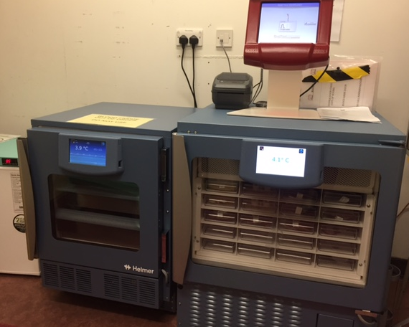  Batch Products fridge  - Unused products must be returned to the lab within 12 hours  - See more details on our Electronic Blood Tracking page | Electronic Blood Tracking - BloodTrack Tx  - BloodTrack Tx is now used for the administration of batch products  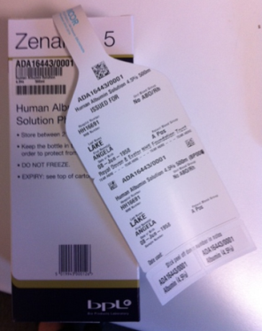  Product number  Product code  - For anti-D and IVIG given in the community setting please record the date administered and return the compatibility tag to “Blood Transfusion Lab, RDE”  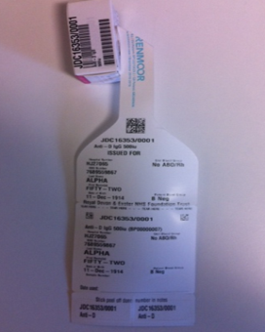  Record the date administered on the tear off part of the tag and return to the lab

Electronic Blood Tracking – remote allocation and sample availability

- From May 2017 the system will offer blood collection by remote allocation. This system is only available to patients eligible for electronic issue, it will mean that you no longer have to phone the lab to request crossmatched blood, ODPs and nursing staff who have been trained to use the system will be able to collect and label blood at the fridge when required for transfusion.
- Remote allocation will be available at the Haemobanks only (currently Main Issue fridge and Main Theatre fridge)
- The system will also provide an easy way to see if there is a valid sample in the lab, the current BloodTrack enquiry screen will have a new button called “sample available”. All medical staff will also be able to access this function.

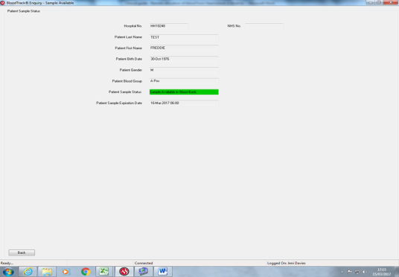
Enter the patient hospital or NHS number to see if there is a valid sample in the laboratory – the system will tell you how long the sample is valid for

- Use the “product available” button to see if the patient is also eligible for remote allocation and if there are any blood units suitable for the patient
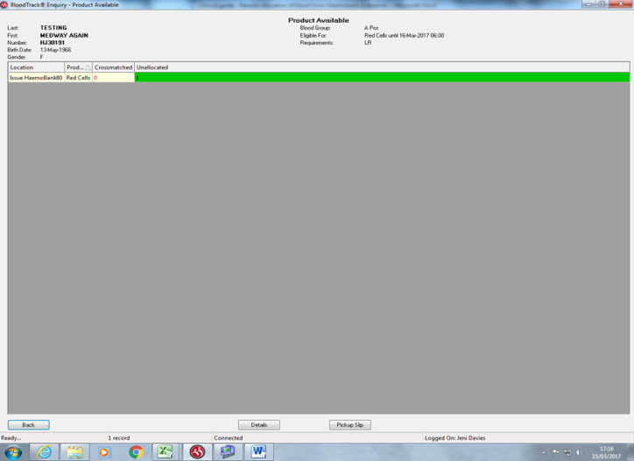
Location of units
Units available for remote allocation

- For more details on using the remote allocation system please see our Electronic Blood Tracking page
- During the first stage of go-live remote allocation from the fridge will only be available via the Main Issue fridge and will be performed by lab staff only – please print a pick up slip and ask at the lab to use the system.
- Further information on when this system will be available more widely will be disseminated nearer the time

Electronic Blood Tracking – sample taking

We are seeing a reduction in rejected transfusion samples for inpatients due to a continued increase in the use of BloodTrack to label the samples.

In order to further reduce rejection rates all staff who take blood samples for transfusion (doctors, nurses, midwives, HCAs) should ensure that they have access to use the system.

To request access and/or training for the sample taking system, or for the remote allocation/sample available system, please contact the Hospital Transfusion Team at rde-tr.HTT@nhs.net

