Microbiology News Update – New culture method for Mycobacteria spp.
5th March 2018

We are pleased to announce the introduction of the BD MGIT – a new liquid culture method for Mycobacterium spp which will replace solid media. We will switch over to this test on 5th March 2018.

The BD BACTEC MGIT Instrument is an in vitro diagnostic instrument designed for the rapid and automated detection of Mycobacteria spp from clinical specimens (except blood).

Positive culture tubes are examined by ZN and Auramine staining for the presence of acid-fast bacilli (AFBs), and then referred to the Mycobacterial Reference Laboratory for further identification and sensitivity testing. We will continue to inform clinicians/wards/public health at every stage of the diagnostic pathway.

All types of clinical specimens, pulmonary as well as extrapulmonary are accepted (except blood).

This method has 2 advantages over traditional culture:
- It is faster – we expect to isolate Mycobacterium tuberculosis in 1-4 weeks (with ~half by 2 weeks) rather than 4-6 weeks. This means we will issue a negative report at 6 weeks – this will be the final report.
- It is more sensitive – this method will (likely) detect all Mycobacteria spp. In the short term we will continue to culture on LJ slopes to further validate this methodology.

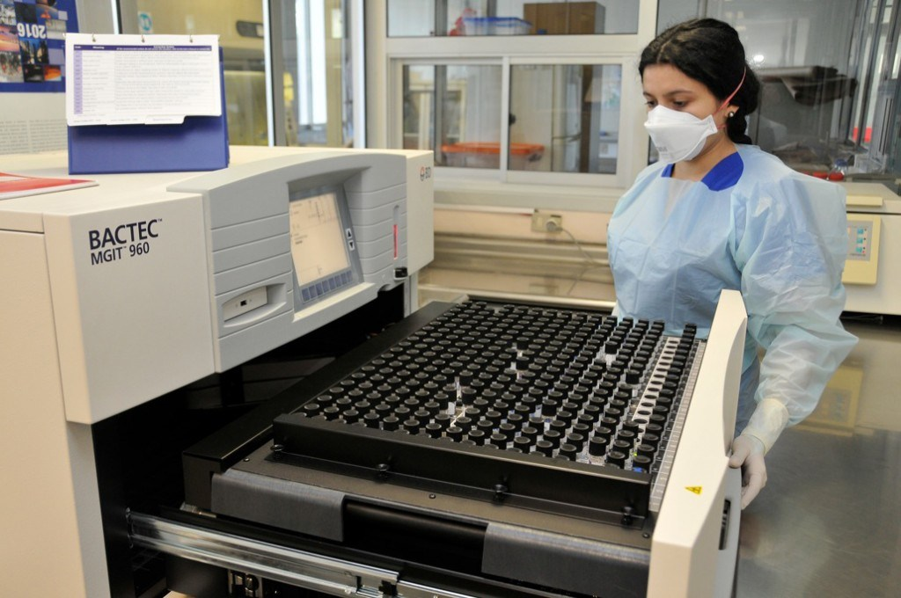

Any comments / questions please contact me in Microbiology:

Cressida Auckland
Consultant Medical Microbiologist
Royal Devon and Exeter
cressida.auckland@nhs.net

Or look on our website:
https://www.exeterlaboratory.com/

