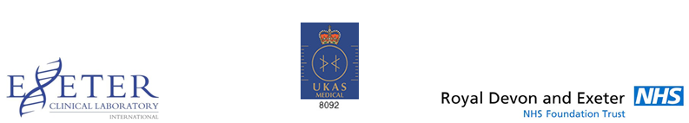

BECKWITH-WIEDEMANN SYNDROME (BWS)

Test | Cost
 | NHS | Non-NHS
Methylation and copy number analysis of imprinted regions on chromosomes 6q24, 7p12, 7q32, 11p15, 14q32, 15q11 and 20q13  Target Turnaround Time (TAT) for a result: 42 calendar days | £600 | £750*
- Please complete an Invoice Details form with details of where the invoice for the test is to be sent and send it to us with the sample.
For BACS or Credit Card payment please contact a Finance Cashier on +44 1392 403957

