GEM® Hemochron100 SOP

LOCATION | Wards, Community Teams
APPARATUS | POCT
AUTHOR  Jessica Turner | AUTHORISED BY  Rhys Johnson

CIRCULATION LIST
Laboratory copies must not be photocopied or amended
Copy number | Location
1 Master copy | Q Pulse
2 Laboratory copy | Hub, www.exeterlaboratory.com

CONTENTS

1. PURPOSE OF THE EXAMINATION 3
2. PRINCIPLE AND METHOD OF THE PROCEDURE 3
3. PERFORMANCE CHARACTERISTICS 3
4. TYPE OF SAMPLE 4
5. PATIENT PREPARATION 5
6. TYPE OF CONTAINER AND ADDITIVES 5
7. EQUIPMENT AND REAGENTS 5
8. ENVIRONMENTAL AND SAFETY CONTROLS 6
9. CALIBRATION PROCEDURES 6
10. PROCEDURAL STEPS 6
11. QUALITY CONTROL PROCEDURES 9
12. INTERFERENCES 11
13. RESULT CALCULATION AND INTERPRETATION 11
13.1 Biological reference intervals/clinical decision values 11
13.2 Reportable interval of results 11
13.3 Alert/critical values 11
13.4 Potential sources of variation 12
14. REPORTING OF RESULTS 12
15. MAINTENANCE 12
16. TROUBLESHOOTING 13
17. REFERENCES 13

GEM® Hemochron100 SOP

PURPOSE OF THE EXAMINATION

Activated Clotting Time (ACT) tests are general coagulation screening tests that are used to measure the functionality of the blood coagulation cascade. The GEM® Hemochron100 System measures whole blood activated clotting time (ACT) using single-use disposable cartridges. Each cartridge contains all of the reagents necessary for a specified test. It is used to assess heparin therapy during cardiac procedures such as Percutaneous Coronary interventions (PCI), Cardiac Electrophysiology procedures (EP’s) and for patients on Cardiac Bypass. Measurement of ACT is required to ensure that the optimum dose of heparin is administered to the patient during and prior to procedures, as overdosing may lead to dangerous bleeding or under dosing may lead thrombosis.

The GEM® Hemochron100 ACT+ and ACT-LR cartridges provide quantitative assays for monitoring heparin anticoagulation during medical procedures. The GEM® Hemochron100 ACT-LR test uses a Celite activator due to its excellent heparin sensitivity. The ACT-LR cartridge has been chosen for use in the Cardiac Cath Labs. The test demonstrates linearity at heparin concentrations up to 2.5 units of heparin per mL of blood.

PRINCIPLE AND METHOD OF THE PROCEDURE

The GEM® Hemochron100 instrument utilises a mechanical endpoint mechanism in which clot formation occurs within the disposable ACT-LR cartridge. Following whole blood sample introduction, the instrument precisely measures 15 µl of blood and automatically moves it into the test channel within the ACT-LR cartridge. The remainder of the blood sample, not needed for testing, is automatically drawn into the waste channel of the cartridge. Sample /reagent /mixing and test initiation are performed automatically. After mixing with the reagent, the sample is moved back and forth within the test channel and monitored for clot formation.

The clot detection mechanism consists of a series of LED optical detectors aligned with the test channel of the cartridge. The speed at which the blood sample moves between the detectors is measured. As clot formation begins, blood flow is impeded and the movement slows. Flow reduction below a predetermined value signals to the instrument that a fibrin clot has formed. An internal timer measures the elapsed time between the start of the test and the clot formation. During the test, the elapsed time is displayed as ACT Celite-equivalent value (CEV) in seconds, not real-time seconds. Upon completion of the test, the whole blood clotting time is displayed and recorded by the instrument.

PERFORMANCE CHARACTERISTICS

The GEM® Hemochron100 ACT-LR analytical measurement range is 65 to 400 Celite Equivalent seconds. The Normal Range Reference Interval was evaluated using fresh whole blood samples from normal, healthy donors (N=120) and cardiac and ECMO patients not receiving UFH treatment (N=120). The normal range study was performed in accordance with CLSI EP28-A3 using ACT-LR on the GEM® Hemochron100 instrument and a nonparametric 95% reference interval was established for each subclass.
Normal Range Reference Interval
Donor Type | N | Lower limit (90% CI) | Upper limit (90% CI)
Normal Donors | 120 | 116 (113-120) | 155 (153-166)
Non-UFH patients | 120 | 83.2 (79-99) | 199.5 (176-226)

LQC samples were tested in accordance with CLSI EP05-A3 with a test design of 1 site, 20 days (non-sequential), 2 runs per day, and 2 replicates per run, across 2 ACT-LR cartridge lots.

Within-run
N |  | Mean(s) |  | SD |  | %CV
Level 1 | 640 |  | 117.7 |  | 10.5 |  | 9.0%
Level 2 | 640 |  | 272.3 |  | 19.1 |  | 7.0%

The study design included a total of 20 test replicates per donor sample (e.g. 2 operators x 5 instruments per operator x 2 test results per instrument). The below sample size was selected as it allows for the evaluation of samples across the measurement range.

Within-instrument
Sample Target Range(s) | N | Mean(s) | SD | %CV
65-145 | 20 | 117.5 | 5.9 | 5.0%
146-226 | 20 | 209.8 | 10.9 | 5.2%
227-307 | 20 | 266.8 | 12.5 | 4.7%
>=308 | 20 | 351.2 | 21.6 | 6.1%

Each institution should establish their own reference normal range and desired target time for specific interventional procedures.

TYPE OF SAMPLE

2mls of fresh whole blood is required for the ACT test. As arterial access is already obtained during the cardiology intervention this is the preferred method.
The access point e.g. radial or femoral arterial sheath must be free of any source of contamination/dilution of the sample (contrast, saline or heparin if obtained arterially). This is achieved by drawing back and wasting 10mls of blood. The 2mls of fresh whole blood is then drawn back into a separate, freshly opened plain syringe, ensuring it does not come into contact with any heparinised saline on the operator’s trolley. The sample must be obtained in a non-heparinised syringe as the use of a heparinised syringe could falsely increase the clotting time of the sample.
Do not use excessive force when expelling the sample. Reject the sample if it is less that 2mls or if it is felt that the sample is contaminated by an outside source of heparin (e.g. the sample syringe was stored in heparinised saline on the physicians trolley) or if the sample is diluted by saline / inadequate aspiration of 10mls of blood prior to the sample being taken. Reject the samples if clots are present. Once drawn into the non-heparinised syringe the sample must be presented to the cartridge within 15 seconds.

N.B. IT IS VITAL THAT THE HEMOCHRON IS READY FOR THE TEST BEFORE DRAWING THE SAMPLE TO ENSURE TIMINGS ARE CORRECT.

PATIENT PREPARATION

Explain and discuss the procedure with the patient to ensure the patient understands and gives verbal consent. Identify the patient verbally/via wristband.
Arterial access is gained by the physician using aseptic techniques. Venepuncture (if arterial access is not still available) should be performed by appropriately trained members of staff aseptically.

TYPE OF CONTAINER AND ADDITIVES

Non-heparinised syringe.

EQUIPMENT AND REAGENTS

Staff must be adequately trained before using these devices. Training is provided by Werfen. For all training requests please contact the Point-of-Care team: rduh.bloodsciencespoct@nhs.net (Eastern) or rduh.poctnorthern@nhs.net (Northern).
Training provided by Werfen will ensure the trainee is competent to use the device. There is also a Trust Medical Devices Competency that is the responsibility of the practice educators and/or ward managers to sign off if necessary for staff members who use the device. This can be accessed via the POC website:

Eastern - https://www.exeterlaboratory.com/point-of-care-testing/policies/
Northern - https://pathologylaboratory.co.uk/pathology-2/departments/point-of-care/point-of-care-policies/

- GEM® Hemochron100
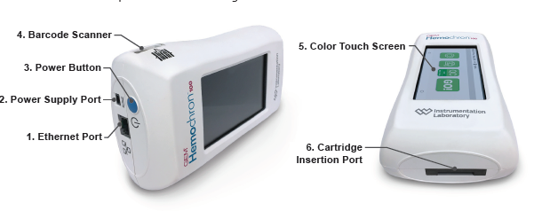

- ACT-LR Cartridges (Catalog no: GACT-LR)
Each box of test ACT LR cartridges contains 45 pouches. The ACT LR test cartridge is a self-contained disposable test chamber preloaded with a dried preparation of thromboplastin, calcium salts, stabilisers and buffers. Each cartridge is individually packaged in a pouch. Cartridge pouches are stamped with a lot specific expiry date.
Always handle the cartridge by the edges rather than touching the surfaces where the optical windows are situated.
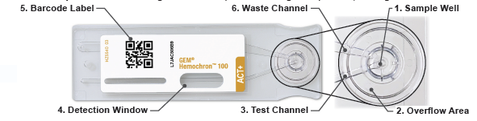

- directCHECK™ Quality Control Products (liquid control material for QC testing)
  - ACT-LR Level 1 (Catalog no: DCGLR-1)
  - ACT-LR Level 2 (Catalog no: DCGLR-2)

- 2 mL or 3 mL plain plastic syringes

Cartridges and Quality Control consumables are on standing order from Werfen. For any alterations to this order, the Area Account Manager Tom Alston can be contacted: talston@werfen.com
Syringes are obtained from Path Stores.

ENVIRONMENTAL AND SAFETY CONTROLS

When refrigerated (2–8°C), the foil pouched cartridges are stable until the marked expiry date, refrigerated cartridges should be allowed up to 60 minutes to come to room temperature before use.
Unopened foil pouched cartridges can be stored at 15–30°C for 12 weeks or until the stated expiry date, whichever is sooner.
For optimal shelf life, it is recommended to open the cartridge pouch immediately before use. Opened cartridges must be used within 5 minutes.

For directCHECK liquid QC, store in refrigerator at 2–8 °C. If stored at this temperature, controls are stable up to the expiry date printed on the box. After removal from the refrigerator the control vials can be stored for 4 weeks at room temperature (15-25°C), however, not beyond the expiry date. Bring to room temperature before use for a minimum of 60 minutes.

All samples and controls should be handled as potentially hazardous material. Disposable gloves must be worn.

CALIBRATION PROCEDURES

The GEM® Hemochron100 is calibrated at the manufacturing facility to test and verify all functions. The instrument is also self-calibrating, as all instrument functions are continuously monitored and verified by the instrument software when a test is performed. The instrument does not require additional calibration by the user.

PROCEDURAL STEPS

Always get the machine ready before taking the sample. Timing is critical and once blood is drawn into the non-heparinised syringe it must be added to the cartridge ASAP and always within 15 seconds from drawing.

- Power on the device.

- Press GO on the home screen and/or insert the ACT LR cartridge into the test chamber on the side of the instrument.

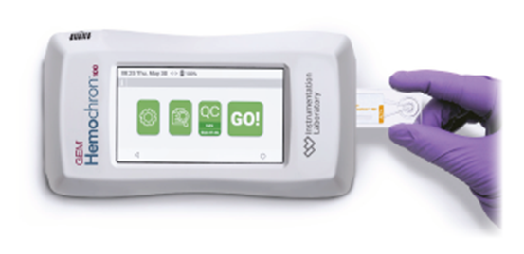

- The device will then request the operator ID, this is the barcode given after training. Press scan and scan in your operator barcode. While the scanner light flashes, hold the instrument at a 90-degree angle to the barcode label.
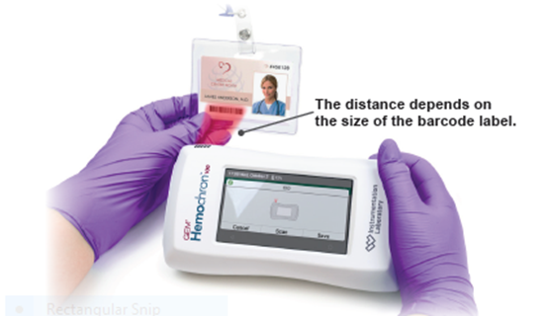

- When the scanner reads the barcode, a beep sounds. Verify that the information was entered into the dialog box correctly. Select Save to retain the information or Cancel to exit without saving.

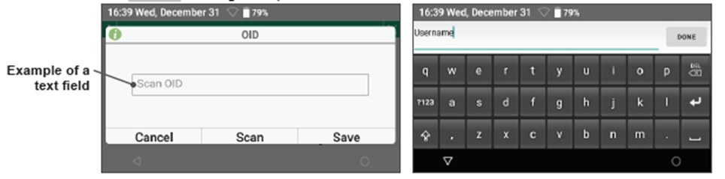
- The Operator/Patient ID can be entered manually. To display the virtual keyboard, touch a text field.

- The device will now request the Patient ID – this is the patient MRN number and can be scanned as above using a patient wristband or can be entered manually as above.
This patient will be retained by the device for two hours from this point so that the patient MRN will not have to be entered multiple times. All subsequent tests will auto-populate the PID field. PLEASE CHECK THAT THE PATIENT IS THE CORRECT ONE. If it is a new patient the MRN must be entered again. After two hours the MRN must be entered.

- Select Save.

- Confirm Y – Yes

- The device will begin the warming process. The instrument will signal when ready with an audible tone and alternating messages ‘Add sample’ and ‘Press Start’.

- The instrument will remain in the ready mode for five minutes. After this time the cartridge must be discarded.

- Obtain blood sample into plain syringe.

- Discard the first drop of blood on a tissue, checking for the presence of clots. Dispense sufficient blood to fill the cartridge well. Excess blood should fall into the area around the cartridge well.
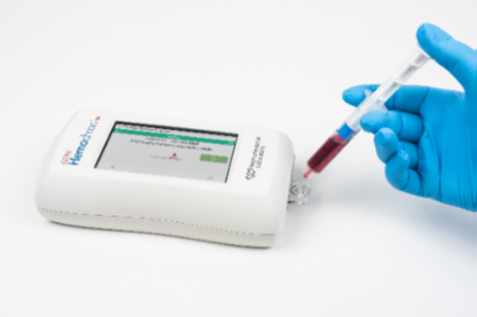

- Press Start.
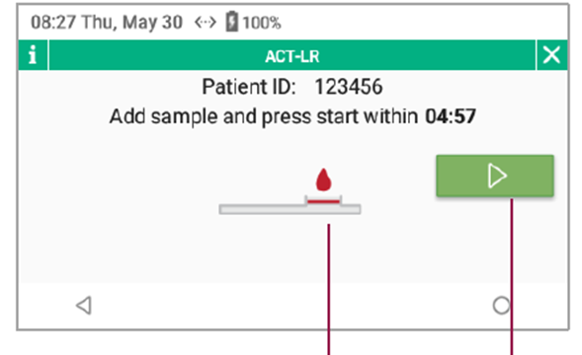

- Test completion will be indicated by a single beep. ACT-LR results will be converted to a reference Celite ACT result and displayed as the Celite equivalent in seconds.
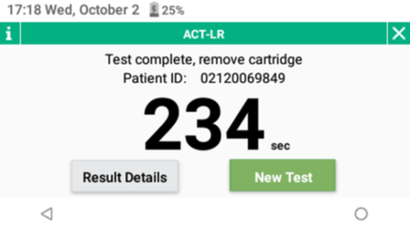

- Remove cartridge and dispose of in yellow clinical waste according to the Trust Waste Management policy.

- To add a note to the result, select Result Details. Here the result can be reviewed. Click on the note icon to add a note.

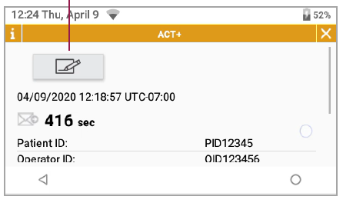

- As with all diagnostic tests, GEM® Hemochron100 test results should be scrutinised in light of a specific patient’s condition and anticoagulant therapy. Any results exhibiting inconsistency with the patient’s clinical status should be repeated or supplemented with additional test data.

In order to review test history:

- Select New Test to start new patient test.
- Select  to access ACT patient-test history.

- Select Result Details to review test information.

QUALITY CONTROL PROCEDURES

Electronic Quality Control (EQC): – This procedure is performed daily and will take approx. 5 minutes. It is done automatically by the device every 8 hours. The system EQC icon will turn yellow 2 hours before EQA process begins.

If the test passes the device will show pass and the EQC icon will be green. The device is ready to use. If the device fails it will automatically retry 3 times. After 3 attempts the EQC icon will turn red. The device cannot be used for patient tests if it fails after the 3rd attempt, please contact the Werfen for technical support (service.uk@werfen.com).

Liquid Quality Control (LQC): – Two levels of directCHECK liquid QC (L1 and L2) are used with the GEM® Hemochron100. They are used to provide assurance that the patient tests being done on the analyser are accurate. The DirectCheck controls supplied are one-time use vials. The vials contain activator solution (calcium chloride) and a breakable glass capsule containing lyophilised rabbit plasma.

Both levels of QC MUST be performed successfully once a week on each analyser. A normal and abnormal directCHECK liquid control (L1 and L2) must be tested to accept each new lot of cuvettes. This can be performed on 1 chosen GEM® Hemochron100 device. The device cannot be used for patient tests if LQC does not pass, please contact the POCT team (rduh.bloodsciencespoct.nhs.net) or Werfen for technical support (service.uk@werfen.com).

- Select QC on home screen.


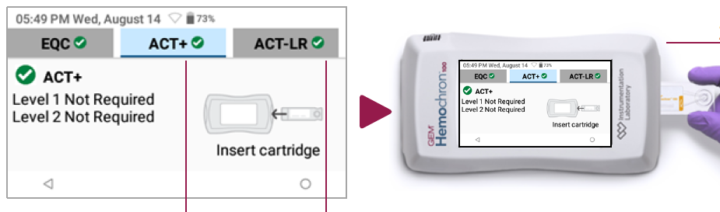
- Select ACT- LR and insert cartridge for ready for LQC.
- Select Scan and scan the QR barcode on Acceptable Performance-Range card, provided on package insert for respective LQC. Select Save.

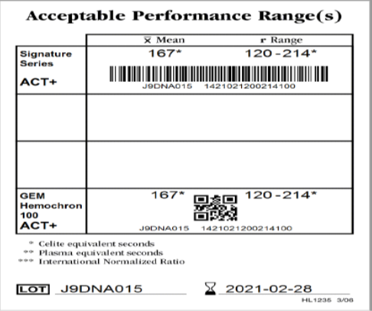

- Enter Operator ID, select Scan and scan your operator barcode.

- Select Save.

- Wait for the analyser to beep and the 5 minute countdown to start before preparing the sample.

- In order to break and prepare the vial, see the instructions below.
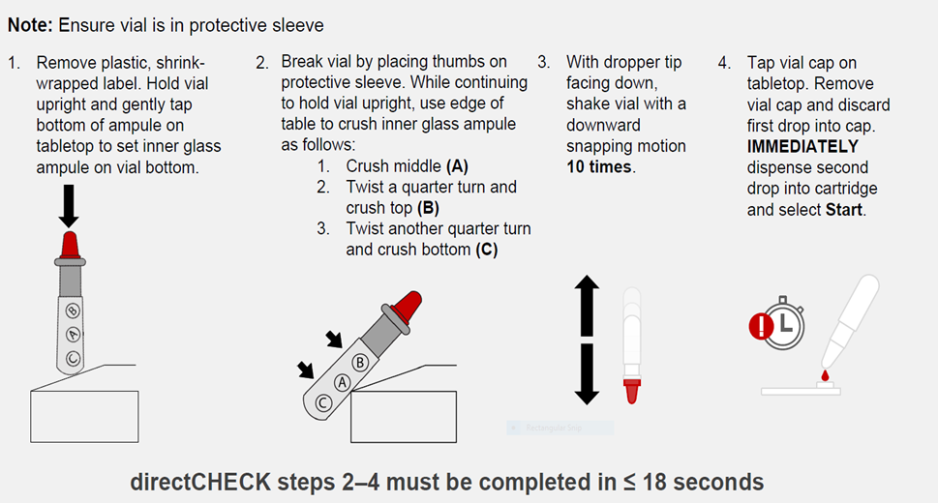

- Press Start.

- When LQC test result is displayed, remove cartridge and dispose of directCHECK material and cartridge as per the Trust Waste Management policy.

- If the quality control is out of range, check the cartridges and quality control are in-date, have been stored appropriately and have come to room temp. Ensure the sample volume is sufficient and that there are no clots in the sample. Repeat the test with a fresh quality control. If the control fails again, contact the POCT team (rduh.bloodsciencespoct.nhs.net).

External Quality Assurance (EQA): – EQA testing gives independent, objective assurance that the instrument is giving accurate results for testing on patient samples and is necessary for continuing quality assurance. Samples will be distributed 3 x per year via POCT Team using the NEQAS scheme.

EQA differs from IQC in that the operator does not know the expected result of the EQA sample at the time of analysis and performance of this test is assessed externally. EQA samples must be analysed as patient samples, following the instructions included with each sample. EQA samples assess the continued performance of the instrument, cartridges and user technique. Any member of staff trained to use the instrument can analyse the EQA samples. It is important that every instrument is tested with each sample.

INTERFERENCES

Results can be affected by the following:
- Foaming or haemolysis of the sample.
- Clotted or partially clotted blood.
- Unsuspected anticoagulation.
- Lupus anticoagulation.

RESULT CALCULATION AND INTERPRETATION

Biological reference intervals/clinical decision values

The manufacturer advises that each institution must establish its own reference and target anticoagulation ranges.

>250 CEV seconds for PCI procedures and >300 CEV seconds for EP procedures.

If the test result does not fit with the clinical picture (abnormally high or low for the amount of heparin given) this must be highlighted to the physician performing the intervention and it must be repeated to ensure no source of dilution/contamination is involved. It is advised that an LQC test is performed to verify the performance of the analyser.

Reportable interval of results

ACT-LR measuring range is 0 to 400 seconds. Results above 400 are outside of the measuring range and the screen will display “Out of range – Hi”.

Alert/critical values

N/A

Potential sources of variation

Test results of the GEM® Hemochron100 instrument are affected by poor technique during blood collection and delivery to the sample well. The accuracy of the test is largely dependent upon the quality of the blood specimen, which is dependent upon the blood sample collection and the transfer of blood to the test cuvette. Results should always be scrutinised in light of a specific patient’s condition or anticoagulant therapy. Any test results exhibiting inconsistency with the patient’s clinical status should be repeated or supplemented with additional diagnostic tests.

Other sources of error:
- Samples with a haematocrit less than 20% or greater than 55% are not recommended due to an optical density outside the level of detection of the instrument.
- Has the test been performed in accordance with the User’s Manual and Standard Operating Procedure.
- Was additional blood added once the first drop has been applied.
- Were the cartridges at room temperature.
- Is the analyser clean.
- Was the sample too small or too large.
- Was there air in the sample.
- Are the cartridges in date.

REPORTING OF RESULTS

Results currently require manually inputting into procedure notes in the patient record in Epic.

MAINTENANCE

- Keep the meter free from dust.
- Remove any Blood spillage on the exterior covers; also ensure that any parts of the instrument that would come in contact with Blood are also cleaned.
- Clean meter with mild detergent, alcohol wipes or warm water – be careful around the cartridge entry point and battery compartment.
- For heavily contaminated meters please contact the laboratory.
- Protect it from extremities and temperature and humidity and handle it with care.
- If the meter is dropped perform a quality control before doing a blood test.

The lithium-ion battery is non-replaceable, and the back of the instrument must not be removed. Battery life is greatly influenced by factors such as environmental temperature, depth of discharge before recharging, and usage pattern. Leaving the power supply connected to the instrument does not decrease battery life but if the instrument is not used for an extended period of time, it is recommended to leave it disconnected from the power supply.
The instrument automatically checks to ensure enough battery power is available when the Operator powers on the instrument and when an Operator runs a test.

The power supply has been selected specifically for use with the instrument. Use only the power supply that is authorised by the manufacturer. Do not use any other power supply.

AUDIT
An electronic device audit will be distributed quarterly by the Point of Care team to check all aspects of the GEM® Hemochron100 ACT devices and that they are being maintained and used as is required. The audit is accessed via a link out every quarter in an email, that will link to a Google form. This should be emailed to a competent staff member to complete. Once completed the form will automatically send response to the Point of Care team.

TROUBLESHOOTING

If an error message is displayed, please refer to the operator manual provided with the meter.
For all queries and general support please call 01392 402912 for advice or email rduh.bloodsciencespoct@nhs.net.
For technical support contact Werfen: service.uk@werfen.com or 01925810141 (option 1, option 1)

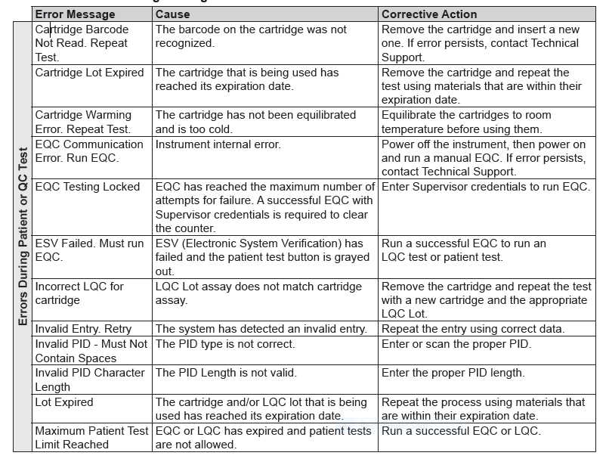
Common errors include:

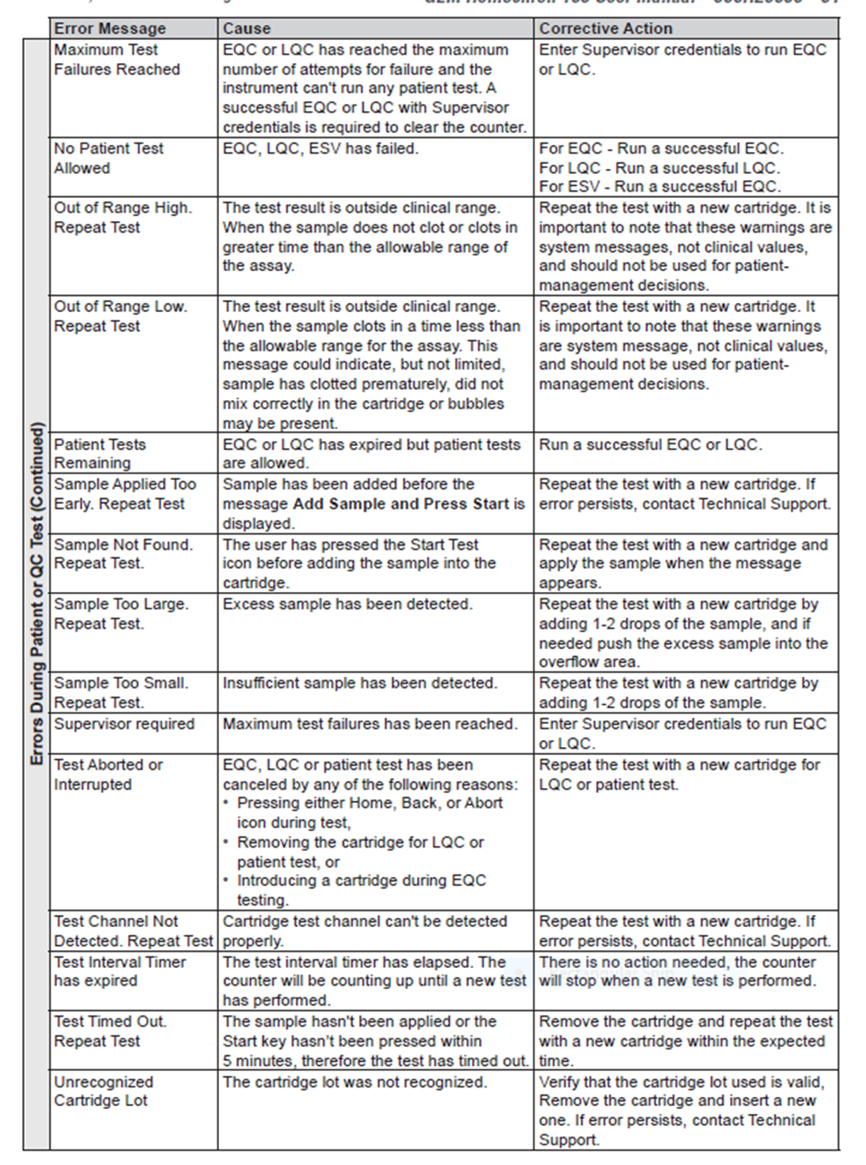

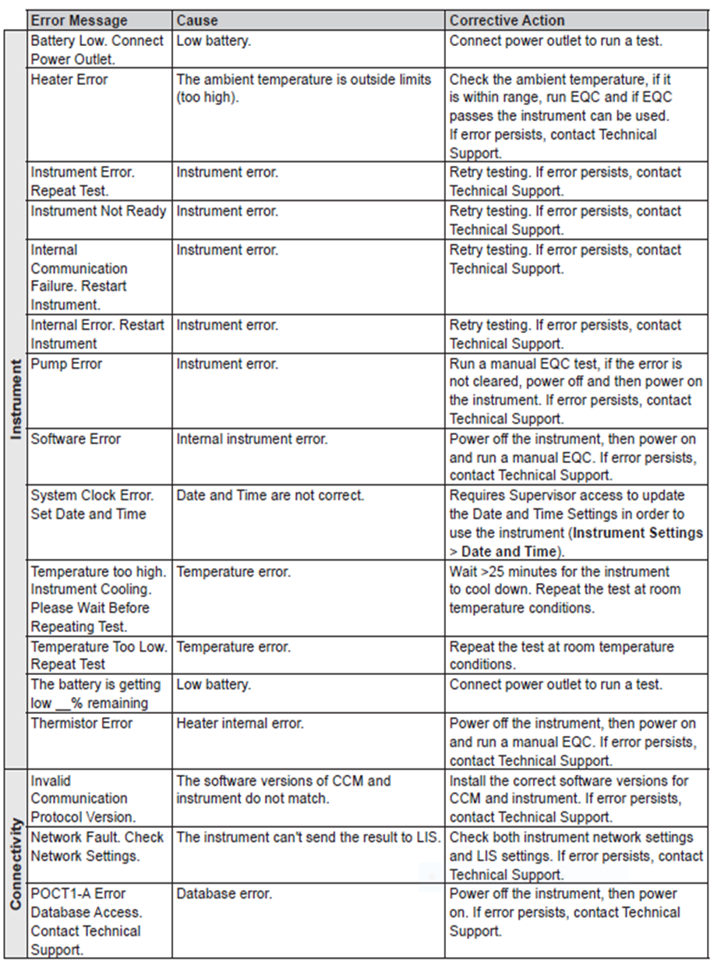

For troubleshooting and/or adjusting settings on the analysers, supervisor logins have been set up for the Point of Care team. Please contact the Point of Care team if any settings require adjusting.

WHAT TO DO TO REPORT AN ADVERSE INCIDENT:
For full policy see Q-pulse CC/LP/0042 or contact laboratory for copy.
- Notify Laboratory Manager or Deputy about the Incident.
- Complete an incident form. In the case of Medical Devices an “Equipment/Consumable/Defective Medicine Report” form should be completed as well. These are found at the back of the incident reporting book. All sections of both forms should be completed in full.
- The forms should be sent to the Risk Management Department as soon as possible.

REFERENCES

- GEM® Hemochron100 User Manual
- GEM® Hemochron100 Quick Reference Guide: Quality Control
- GEM® Hemochron100 Quick Reference Guide: Patient Test
- GEM® Hemochron100 ACT-LR Cartridge Package Insert
- GEM® Hemochron100 directCHECK Package Insert

