NOVA StatStrip Xpress®2 Blood Glucose/Ketone Meter SOP

LOCATION | Wards, Community Teams
APPARATUS | POCT
AUTHOR  Rhys Johnson | AUTHORISED BY  Aled Lewis

CIRCULATION LIST
Laboratory copies must not be photocopied or amended
Copy number | Location
1 Master copy | Q Pulse
2 Laboratory copy | Hub, www.exeterlaboratory.com

CONTENTS

1. PURPOSE OF THE EXAMINATION 3
2. PRINCIPLE AND METHOD OF THE PROCEDURE 3
3. PERFORMANCE CHARACTERISTICS 4
4. TYPE OF SAMPLE 4
5. PATIENT PREPARATION 4
6. TYPE OF CONTAINER AND ADDITIVES 5
7. EQUIPMENT AND REAGENTS 5
8. ENVIRONMENTAL AND SAFETY CONTROLS 6
9. CALIBRATION PROCEDURES 6
10. PROCEDURAL STEPS 6
11. QUALITY CONTROL PROCEDURES 7
12. INTERFERENCES 8
13. RESULT CALCULATION AND INTERPRETATION 8
13.1 Biological reference intervals/clinical decision values 8
13.2 Reportable interval of results 8
13.3 Alert/critical values 8
13.4 Potential sources of variation 9
14. REPORTING OF RESULTS 9
15. MAINTENANCE 9
16. TROUBLESHOOTING 10
17. REFERENCES 10

NOVA StatStrip Xpress®2 Blood Glucose/Ketone Meter SOP

PURPOSE OF THE EXAMINATION

This operating procedure outlines the use and management of NOVA StatStrip Xpress®2 Meters within the Trust for the measurement of Glucose and Ketones in blood.

The RDUH recognises that the use of POCT devices is an integral part of healthcare, but that there is an inherent risk in doing so. The RDUH aims to minimise this risk by utilising the Point of Care testing policy and this operating procedure as a framework to monitor and audit the devices.
The object of this SOP is to:

- Ensure the principles of best practice are used.
- Promote safety, reliability and suitability of the equipment and procedures
- Ensure that the use of Blood Glucose/Ketone Meters are a value added activity and that no harm is rendered to any patient as a result of mismanagement or inappropriate use.

PRINCIPLE AND METHOD OF THE PROCEDURE

Measurement of blood glucose/ketones using meters and strips, either by patients themselves or by nursing staff, is a well-established procedure. The NOVA StatStrip Xpress®2 blood glucose/ketone meters are light portable meters that provide accurate results in seconds. When a drop of blood is placed on the test strip, the glucose or ketones in the blood reacts with the chemicals on the test strip, producing a small electrical current. The current is measured and then a result is displayed by the NOVA StatStrip Xpress®2 blood glucose/ketone meter. The size of the current depends on the amount of glucose or ketones in the blood sample.

Glucose measurement is based on electrochemical biosensor technology using the enzyme glucose dehydrogenase - FAD. The glucose in the sample is oxidized to produce glucoronic acid. The electrical current resulting from this enzymatic reaction is measured and correlated to glucose concentration by the meter. The magnitude of the current is proportional to the concentration of glucose in the sample. The test strip is calibrated to display the equivalent of plasma glucose values to allow comparison of results with laboratory methods.

Whole blood ketone monitoring is important for managing adult and paediatric patients with diabetes ketoacidosis (DKA). In addition ketone measurement is also important in monitoring adults and neonates with metabolic disease, monitoring patients on fasting regimes, managing children following a ketogenic diet and in managing alcoholic ketoacidosis. Serial monitoring of blood ketone is important in managing the treatment and recovery of DKA patients. Using the same electrochemical biosensor technology, β-hydroxybutyrate (β-ketone) is converted by β-hydroxybutyrate dehydrogenase and the magnitude of electrical current resulting from this enzymatic reaction is proportional to the amount of β-hydroxybutyrate present in the sample.

PERFORMANCE CHARACTERISTICS
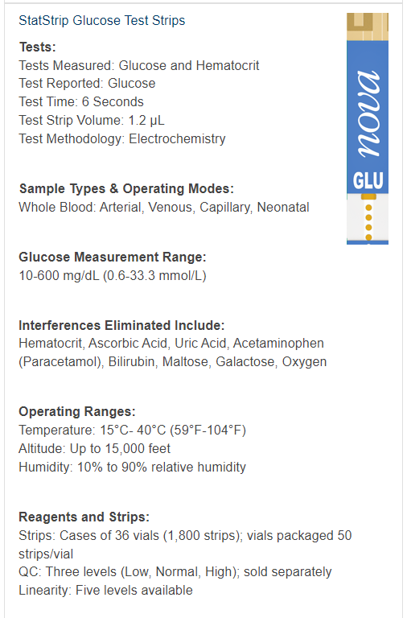
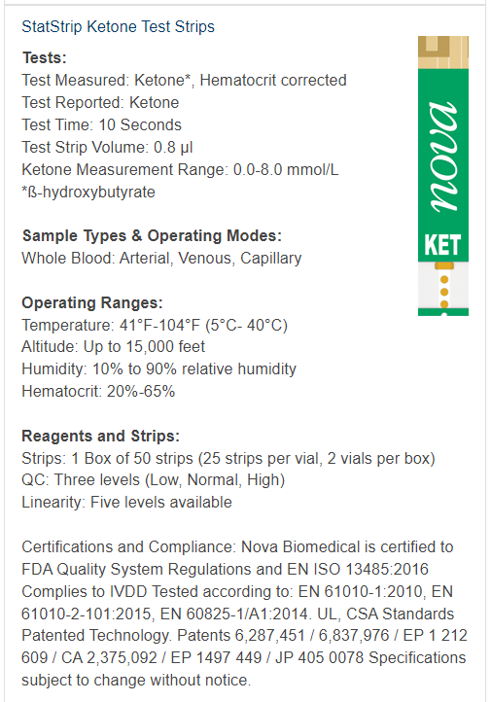

TYPE OF SAMPLE

A blood drop is required to perform a blood glucose/ketone test. Capillary blood can be used. Venous, arterial, or neonatal blood may also be used only if drawn by healthcare professionals. Take caution to clear arterial lines before the blood sample is drawn and applied to the test strip.

Fresh venous and arterial blood samples containing the anticoagulants EDTA, lithium heparin, or sodium heparin are acceptable. Iodoacetate or fluoride-containing anticoagulants are not recommended.

NB – Do not use serum or plasma

PATIENT PREPARATION

When performing peripheral stabs staff must adhere to all the relevant Trust policies. These include the Trust Universal Precautions Policy and the Trust Infection Control Policy.
- Gain consent from the patient.
- Disposable gloves must be worn.
- The patient’s and staff members hands must be thoroughly cleaned and dried prior to blood collection. Note: The use of alcohol swabs to prepare the puncture site can adversely affect the result obtained.
- Do NOT use the thumb or index finger for sampling, and always use the side of the finger.
- Remember that the quality of the blood sample you use in this test will have a major impact on the quality of the result.

TYPE OF CONTAINER AND ADDITIVES

This is near patient testing at the bedside.
Patient sample applied directly onto strip therefore no container used.

EQUIPMENT AND REAGENTS

Staff must be adequately trained before using these devices. Training is provided by Nova. For all training requests please contact the Point-of-Care team: rduh.bloodsciencespoct@nhs.net (Eastern) or rduh.poctnorthern@nhs.net (Northern).
Training provided by Nova will ensure the trainee is competent to use the device. There is also a Trust Medical Devices Competency that is the responsibility of the practice educators and/or ward managers to sign off if necessary for staff members who use the device. This can be accessed via the POC website:

Eastern - https://www.exeterlaboratory.com/point-of-care-testing/policies/
Northern - https://pathologylaboratory.co.uk/pathology-2/departments/point-of-care/point-of-care-policies/

For Residential Homes managed by the Northern POC team, glucose testing is a delegated task by the clinical educator team. This means that any staff member that is delegated this task will require training from Nova and clinical training from the clinical educator team before performing the task. This does not apply for Nursing Homes because there is a registered nurse on-site at all times.

To begin testing you will require the following items:
- The NOVA StatStrip Xpress®2 blood glucose/ketone meters.
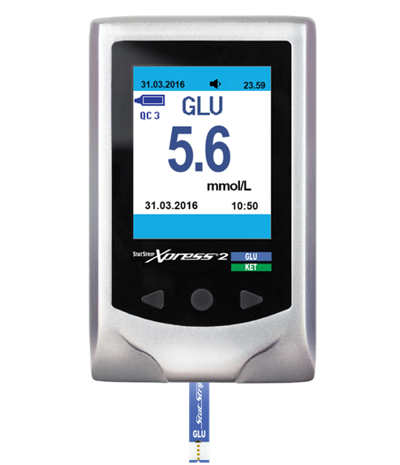

- StatStrip Glucose Test Strips
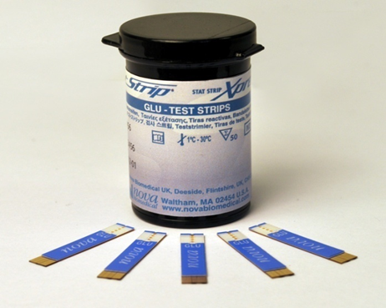

- StatStrip Ketone Test Strips
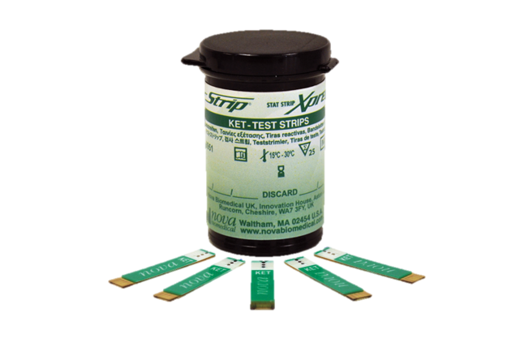

- Quality Control Solution
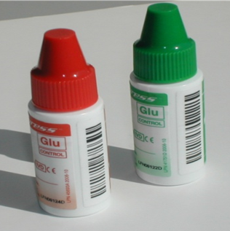

- Lancing device (Unistik 3)
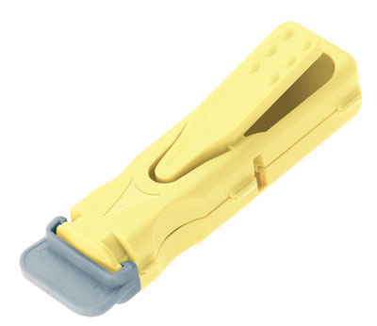

- Log Book

Northern: To order quality control solutions, logbooks, testing strips or new/replacement devices please email rduh.poctnorthen@nhs.net for Northern sites/wards.

Eastern: To order quality control solutions, logbooks or new/replacement devices please email and rduh.bloodsciencespoct@nhs.net for Eastern sites/wards.
Testing strips are ordered via pharmacy ordering lists on MyCare for Eastern sites/wards:
- StatStrip Beta-Ketone Test Strips, 50 strips, Pack of 1 [297070]
- StatStrip Glucose Test Strips, 100 strips, Pack of 1 [297069]

For Eastern sites that are a part of Devon Partnership Trust (DPT), test strips will be sent on a six monthly basis as a standing order because MyCare cannot be accessed in DPT. This order is adjustable via rduh.bloodsciencespoct@nhs.net.

ENVIRONMENTAL AND SAFETY CONTROLS

Controls solutions should not be stored above 30 degrees or should not be frozen.

Control solutions are only stable for 3 months once opened.
Bottles MUST be dated on opening.

Test strips should be stored between 15 - 30 degrees and must not be frozen.

Glucose test strips are only stable for 6 months once opened.
Ketone test strips are only stable for 3 months once opened.
Bottles MUST be dated on opening.

CALIBRATION PROCEDURES

All test strip lots are standardised to the same calibration, traceable to NIST reference standards, which eliminates the need to calibrate with every change in lot number. The design of StatStrip® utilises a patented multi-well and multilayer strip sensor technology that incorporates control wells that measure and correct for haematocrit interference and also corrects for other common interfering substances. The electrochemistry technology is layered onto a gold platform providing a stable and robust surface for the electrochemical reaction kinetics. The gold layer also provides a platform for batch-to-batch manufacturing consistency and reproducibility that eliminates the need for batch-to-batch calibration.

PROCEDURAL STEPS

- Ensure you are wearing fresh gloves. For capillary samples, clean the patient skin and ensure it is dry before performing finger prick

- Glucose strips are blue and Ketone strips are green. Select the strip you require, check the discard date on the side of the bottle and replace the bottle cap immediately.

- Gently push the strip into the bottom of the meter, gold end first with the coloured side facing up. This will turn on the machine.

- The meter will recognise the strip type and “Glu” or “Ket” will appear on screen along with a droplet image.

- Place a drop of patient blood in the centre of the very end of the strip—NOT on the top. See that the sample is drawn into the strip. Keep the meter flat during analysis.

- Results will take 6 seconds for glucose and 10 seconds for ketones. When ready, results will display on the screen for 60 seconds or until you remove the strip.

- Immediately record the patient’s results in their patient chart.

- Glucose results outside of 2.8 and 20 mmol/L or that are not in keeping with the clinical picture, should be verified by sending a venous sample of blood to the laboratory for a random blood glucose measurement. If glucose result is less than 0.6 mmol/L, meter displays LO. If glucose result is greater than 33.3mmol/L, meter displays HI.

Ketone results >0.6 mmol/L may be significant and should be discussed with a senior staff member. If ketone result is less than 0.1 mmol/L, meter displays LO. If ketone result is greater than 8.0mmol/L, meter displays HI.

- Repeat unexpected results using a fresh strip.

- Discard used strips into a sharps container. Return the meter to its meter box.

QUALITY CONTROL PROCEDURES

Two levels of QC (1 and 3) are used with the NOVA StatStrip Xpress®2 meter. They are used to provide assurance that the patient tests being done on the analyser are accurate.

For glucose testing, both levels of QC MUST be performed successfully once a week.
For ketone testing, both levels of QC MUST be performed successfully ad-hoc, i.e. every time a patient test requires running unless done within previous 24 hours.
The meter must also be Quality Controlled each time new lot of testing strips are opened and when each new batch of Quality Control received.

- Glucose strips are blue and Ketone strips are green. Select the strip you require, check the discard date on the side of the bottle and replace the bottle cap immediately.

- Gently push the strip into the bottom of the meter, gold end first with the coloured side facing up. This will turn on the machine.

- The meter will recognise the strip type and “Glu” or “Ket” will appear on screen along with a droplet image.

- Place a drop of quality control in the centre of the very end of the strip—NOT on the top. See that the sample is drawn into the strip. Keep the meter flat during analysis.

- Results will take 6 seconds for glucose and 10 seconds for ketones. When ready, results will display on the screen for 60 seconds or until you remove the strip.

- Immediately record the quality control result in the quality control logbook. Check if the results are within the acceptable range. The ranges are written on the first page on the book and also on the side of the quality control bottles.

- Remember that the QC log book is a legal document and need to be stored for 8 years. All completed books should be returned to biochemistry for storage.

- If the quality control result is outside the range repeat the test.
Also, check that the strips and quality control is within its expiry date, has been stored correctly, and there is no visible contamination of the device or consumables. If the problem persists please call 01392 402912 for advice or email rduh.bloodsciencespoct@nhs.net (Eastern) or call 01271 349114 or email rduh.poctnorthern@nhs.net (Northern).

- External Quality control solutions will be sent to each ward/meter user on a monthly basis and should be treated as a patients’ samples. On receipt of the sample, analyse immediately and return the result to the Point-of-Care team via the URL provided, following the instruction on the attached compliment slip.

Please note:
A Non-Return and/or Poor Performance for EQA testing in two consecutive months or for four months in a 12 month period will be sent a warning email.
A Non-Return and/or Poor Performance for EQA testing in three consecutive months or for six months in a 12 month period will be reported via DATIX as a non-compliance and sent an audit for completion in the event of repeated poor performance.

INTERFERENCES

The StatStrip Xpress®2 Meter exhibits no interference for ß-Ketone from the following substances up to the following concentration levels:
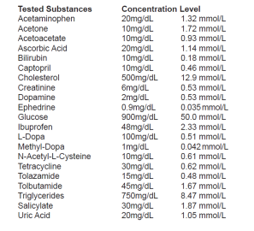

The StatStrip Xpress®2 Meter exhibits no interference for Glucose from the following substances: Hematocrit, Ascorbic Acid, Uric Acid, Acetaminophen (Paracetamol), Bilirubin, Maltose, Galactose, Oxygen

RESULT CALCULATION AND INTERPRETATION

Biological reference intervals/clinical decision values

Normal adult blood ketone level is <0.6mmol/L
Normal adult blood glucose levels are between 2.8-20.0 mmol/L

Reportable interval of results

Analytical measurement range for Ketone is 0.1-8.0 mmol/L
Analytical measurement range for Glucose is 0.6-33.3 mmol/L

Alert/critical values

If glucose result is less than 0.6 mmol/L, meter displays LO. If glucose result is greater than 33.3mmol/L, meter displays HI.
If ketone result is less than 0.1 mmol/L, meter displays LO. If ketone result is greater than 8.0mmol/L, meter displays HI.

Users are alerted on the meter when the Ketone result is greater than 0.6 mmol/L. Ketone results >0.6 mmol/L may be significant and should be discussed with a senior staff member.

Glucose results outside of 2.8 and 20mmol/L or that are not in keeping with the clinical picture, should be verified by sending a venous sample of blood to the laboratory for a random blood glucose measurement.

Potential sources of variation

The MHRA recommend that therapeutic decisions should not be based on a capillary samples in these circumstances:
- Severe Dehydration
- Hypotension
- Shock
- Peripheral Circulatory Failure

Further Limitations

- The test strip should not be used on newborns
- The test strip should not be used to diagnose DKA. The enzyme used in Blood Ketone devices can influence the ketone specificity and it has been reported that the accuracy of ketone measurement can be influenced by the presence of acetoacetate. Acetoacetate is present in patients with DKA and any interference can influence the reliability of a ketone measurement for serial monitoring of DKA patients.
- Extremes of humidity may affect results (>90% or <10%)
- The acceptable haematocrit range for testing is 25% - 60%

REPORTING OF RESULTS

Results must be recorded immediately on the patient’s chart on EPIC or record sheet, along with the date, time, patient’s name and NHS/hospital number and the operator’s name. All details must be written clearly and legibly.

The result is only available for 60 seconds on the screen before the meter automatically turns off if the strip is not removed.
In the event that a result is not recorded before the screen clears the result then the test must be repeated.
NO attempt should be made to retrieve the result from the meter’s memory. This is because there is no positive patient ID attached to the result in the meter

MAINTENANCE

- Keep the meter free from dust.
- Remove any Blood spillage on the exterior covers; also ensure that any parts of the instrument that would come in contact with Blood are also cleaned.
- Clean meter with mild detergent, alcohol wipes or warm water – be careful around the strip entry point and battery compartment.
- Heavily contaminated meters please contact the laboratory.
- Protect it from extremities and temperature and humidity and handle it with care.
- If the meter is dropped perform a quality control before doing a blood test.

If the batteries require changing a red battery icon indicates the batteries are low and a maximum of 10 further tests will be possible before they run out of power.
- Remove the rear battery cover and replace the two AAAs with high quality alkaline batteries, ensure correct positioning of positive and negative terminals, and replace the battery cover. After 3 seconds the meter will go into its setup mode.
- The time format is displayed first, use the arrow keys until ‘24 hour’ is displayed then press the central button to set and move to the time, adjust this as required using the buttons in the same way. Set the date and the beep as ‘on’ the display will then show ‘end’.
- Set-up can also be entered by pressing the central button for more than 3 seconds.

TROUBLESHOOTING

If an error message is displayed, e.g. ‘E1’, please refer to the troubleshooting guide in the manual that was provided with the meter.
For all queries and questions please call 01392 402912 for advice or email rduh.bloodsciencespoct@nhs.net (Eastern) or call 01271 349114 or email rduh.poctnorthern@nhs.net (Northern).

WHAT TO DO TO REPORT AN ADVERSE INCIDENT:
- Notify Laboratory Manager or Deputy about the Incident.
- Complete an incident form. In the case of Medical Devices an “Equipment/Consumable/Defective Medicine Report” form should be completed as well. These are found at the back of the incident reporting book. All sections of both forms should be completed in full.
- The forms should be sent to the Risk Management Department as soon as possible.

REFERENCES

Nova Biomedical Uk
Innovation House
Aston Lane South
Runcorn
Cheshire
WA7 3FY

Nova UK, Support support@novabiomedical.co.uk

